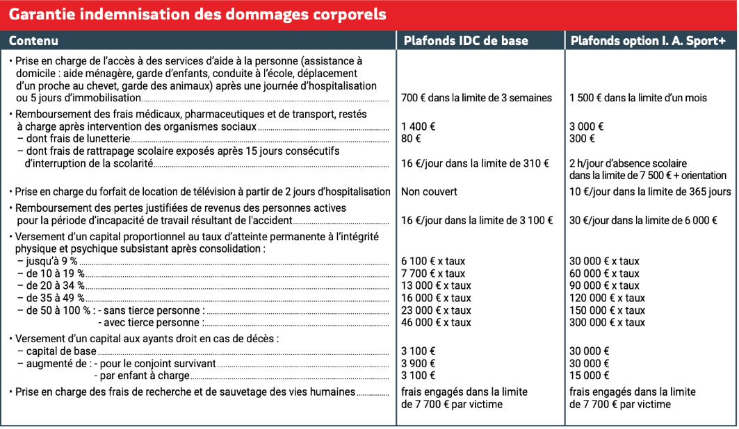
ASSURANCE COMPLEMENTAIRE FACULTATIVE

